**BIRLA INSTITUTE OF TECHNOLOGY AND SCIENCE, PILANI**

**DEPARTMENT OF COMPUTER SCIENCE AND INFORMATION SYSTEMS**

**Artificial Intelligence (BITS F444/ CS F407)**

**I Semester 2019-20**

**Programming Assignment-2**

**Coding Details**

**(September 27, 2019)**

*Instruction: Type the details precisely and neatly*

1. ID 2017A7PS0093P

Name AYUSH JAIN

1. Mention the names of Submitted files :
   1. minesweeper.py
   2. graphs.py
   3. bomb.png
   4. flag.png
2. Total number of submitted files: 1
3. Name of the folder : 2017A7PS0093P_ASS2
4. Have you checked that all the files you are submitting your name in the top? YES
5. Have you checked that all the files you are submitting are in the folder as specified in 4 (and no subfolder exists)?Yes
6. Problem formulation
   1. State representation: 2 dimensional list of M X N size, each cell having attributes like “number” of surrounding mines, is_flagged, is_clicked, is_mine.
   2. How is the Initial state generated? On clicking the start button, it generates random mines. A random number is generated which specifies the location which is clicked. Based on it the open area is opened.
   3. What is the goal state? The goal state is when all the mines have been flagged.
   4. Are there more than one goal states? If yes, then describe all the goal states. No, there is only one goal.
   5. Do you view the goal state as a state reaching its optimal heuristic value in a search landscape? Give details. Yes, So basically the heuristic is designed in a way that it will be maximum when it reaches the goal state, and that value cannot be greater than the value at goal state.
   6. State representation in Python (name the construct and give one small example of a state)

List of widgets [[obj1, obj2], [obj3, obj4]], with each object having attributes: is_clicked, is_flagged, is_mine, number(number of surrounding miles), is_revealed. It is defined as “Tile” class inside minesweeper.py

1. NextState() function description: Given the coordinates (x, y) of the tile clicked, it opens up the area according to description given in the problem description. It marks the is_clicked of (x, y) tile as true, and is_revealed of all the tiles as True
2. Heuristic functions
   1. Is the heuristic function applied on a cell or on a state? Applied on a state, i.e. entire war field.
   2. Define and explain the heuristics (in words) used in your program. Specify the input and output to each function in detail
      1. h1 : It takes the whole state as input and returns the number of mines which it can surely detect” using the opened up numbers. For tie breaking an additional heurestics is developed which takes the state as input and returns the number of revealed areas. Note: It does not tell whether in the open area, there is a mine or not, as discussed with the instructor.
      2. h2 :It returns the sum of all the opened up numbers. The intuition behind this is the “loosening the constraints” discussed in the class. We assume that total sum denotes the total exposable mines.

Again the same tie breaking algorithm is used.

* 1. Compute (manually) the heuristic values for the following three states state 1, 2 and goal state as given in the following three figures 1,2 and 3 respectively. Write the values below appropriately.

State1 : h1 = 5 , h2 = 31

State2 : h1 = 4 , h2 = 28

State2 : h1 = 4 , h2 = 29

Goal state : h1 = 10(number of mines) , h2 = Depends on individual game, as sum of opened tiles in goal.

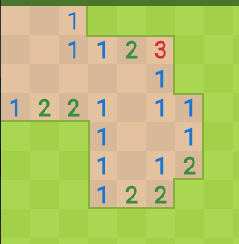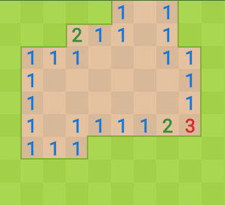

1. Hill Climbing (T1) technique
   1. Code status (implemented fully/ partially/ not done) Partially
   2. Write the sequence of steps followed by you (choose words from - First click, next state, all next states, compute heuristic value, cell, state, open area, closed area, mine etc.) First click, open-area based on first click, click on the Next button which invokes the computation: all next states stored in a list, sent to heuristic, based on heuristic, next state to go is decided. On selected state, next state function is invoked.
   3. Print the pre-computed values (15 by 15, with 100 mines)

R1 = 14442 bytes R2 = 5.3sec R3 = 98 mines R4 = 18 R5 = 16(clicks on mines sometimes initially)

R6 = 29.7 R7 = 18 R8 = 16 R9 = R10 =

* 1. Cut and paste the images of graphs G1, G2, G3 and G4 below

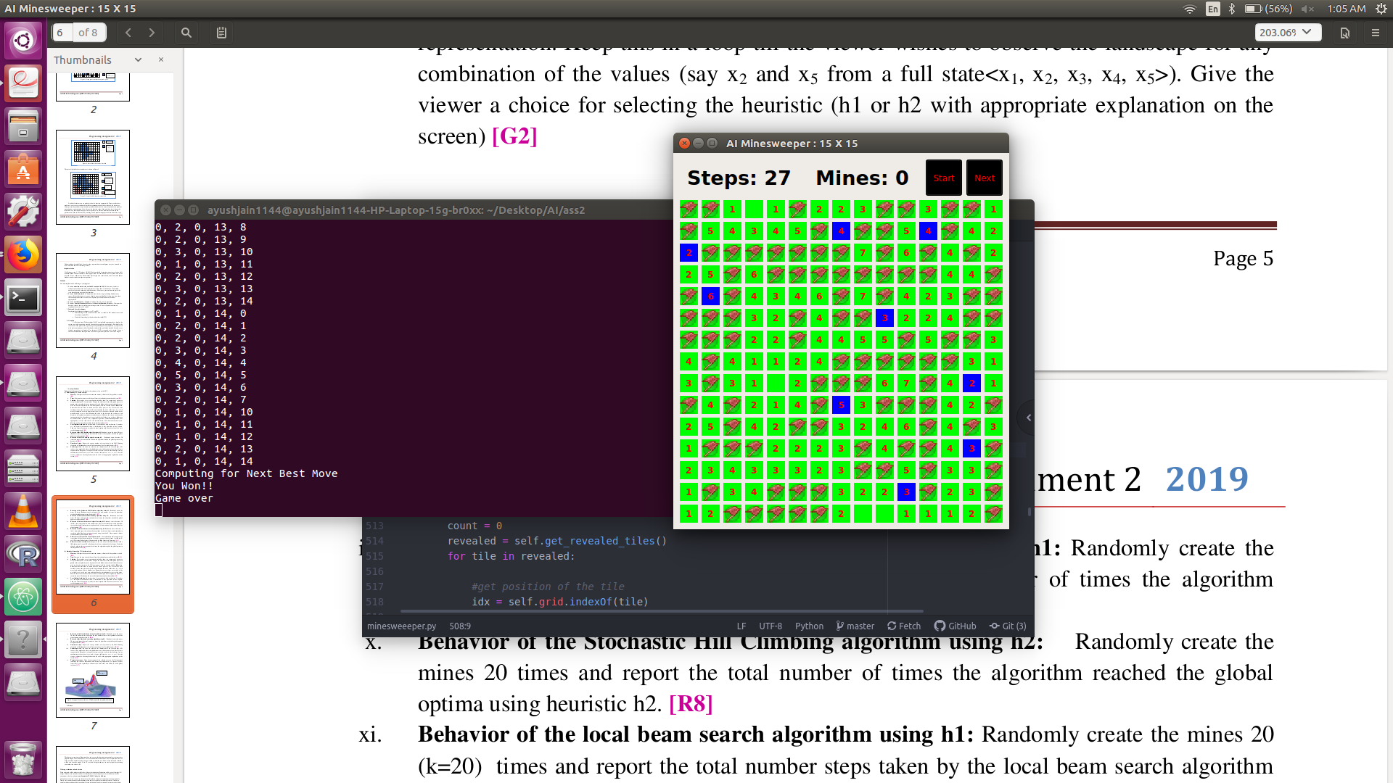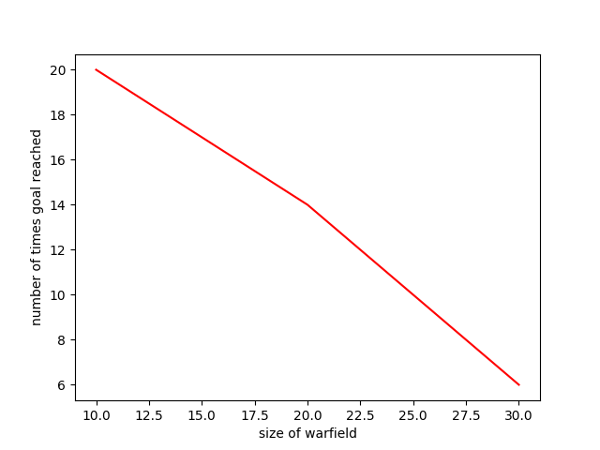

* 1. Are you posing the problem as a maximization problem or minimization problem? Discuss why. Maximization problem. The heuristic value counts the maximum mines detectable from a state. We want to achieve a state where all mines can be detected, which is a goal state.
  2. Discuss how you view the changing values of heuristics as you proceed. The values increase in a state which opens a lot of open state as it correlates with number of mines which can be detected.
  3. Discuss the state which represented suboptimal solution? Why? When I increased the density of mines close to 90%, then I observed that it clicked on mines. The reason was that my heuristic calculates the number of mines which can be spotted from open up area. But the nextState person shows cruelty in the form that it doesn’t tell if it is a mine or not, also my tie-breaking is not helping as it again shows the same values when only one square can be opened up. It typically happens during later-half of the game and with high density of mines.

1. Simulated annealing (T1) technique
   1. Code status (implemented fully/ partially/ not done) Partially
   2. Write the sequence of steps followed by you (choose words from - First click, next state, all next states, compute heuristic value, cell, state, open area, closed area, mine etc.) First click, open-area based on first click, click on the Next button which invokes the computation: all next states stored in a list, sent to heuristic, based on heuristic, next state to go is decided. On selected state, next state function is invoked.
   3. Print the pre-computed values

R11 = R12 = R13 = R14 = R15 = R16 =

* 1. Cut and paste the images of graphs G5, G6 and G7 below
  2. Discuss the temperature range used. 0 - 100
  3. Discuss the probability computation. This is where I am facing a lot of difficulty, exponential schedule is not working because the value is too high and remains a quite a lot random, my program generally ends in 15 steps normally.
  4. How are you selecting the bad moves?
  5. Are you posing the problem as maximization problem or minimization problem? Discuss why. Maximization, same as in hill climbing.
  6. Discuss how you view the changing values of heuristics as you proceed.

1. GUI details
   1. Created the GUI (yes/ No): Yes
   2. Have created it according to the specifications?(yes/No) Yes
   3. Which module of Python used for creating graphics? PyQT5
   4. Is this under the standard Python library/ Matplotlib/ PyQT or not? Yes
   5. If not, why?
2. Compilation Details:
   1. Code Compiles (Yes/ No):____YES__________
   2. Mention the .py files that do not compile:___________________________________________
   3. Any specific function that does not compile:_______________________________________
   4. Ensured the compatibility of your code with the specified Python version(yes/no)_______YES_____
   5. Instructions for compilation of your files mentioning the multi file compilation process used by you (We may use the replica of these for compiling your files while evaluating your code) python minesweeper.py
3. Driver Details: Does it take care of the options specified earlier(yes/no):__YES_________
4. Execution status (describe in maximum 2 lines) COMPLETE

1. Any other detail: ____________________________________________________________________ ____________________________________________________________________________________
2. Declaration: I, ___Ayush Jain_________________________ (name) declare that I have put my genuine efforts in creating the python code for the given programming assignment and have submitted only the code developed by me. I have not copied any piece of code from any source. If the code is found plagiarized in any form or degree, I understand that a disciplinary action as per the institute rules will be taken against me and I will accept the penalty as decided by the department of Computer Science and Information Systems, BITS, Pilani.

ID_________2017A7PS0093P_____________________ Name:_________AYSUH JAIN_________________

Date: _______26 SEPTEMBER, 2019_______

******************************************************************************* Should not exceed six pages